**Design Aspects of Lithium-ion Battery for Electric Vehicles**

A thesis submitted in partial fulfilment

of the requirements for the award of the degree of

**Master of Technology**

In

**Mechanical Systems Design**

Submitted by

Prateek Gandhi

20SD06011

Under the Supervision of

Dr. B. Pattabhi Ramaiah



School of Mechanical Sciences

Indian Institute of Technology, Bhubaneswar

Argul, Jatni, Bhubaneswar - 752050

Month, Year

यांत्रिकी विज्ञान विद्यापीठ/School of Mechanical Sciences

**​भारतीय प्रौद्योगिकी संस्थान भुवनेश्वर**/Indian Institute of Technology Bhubaneswar

**जटनी - 752050**/Jatni–752050,**खोर्धा/** Khordha,**ओड़िशा**, **भारत/** Odisha, India

**APPROVAL OF THE VIVA-VOCE BOARD**

Date:

Certified that the thesis entitled “TITLE OF THE THESIS” submitted by “NAME OF THE STUDENT”, a postgraduate student of Manufacturing Engineering (ME), to the School of Mechanical Sciences, Indian Institute of Technology, Bhubaneswar for the award of Master of Technology degree has been accepted by the internal and external examiner/examiners. The student has successfully defended his thesis in the viva-voce examination.

Name of first Supervisor Name of second Supervisor

**(Supervisor)** **(Supervisor)**

Name of Examiner Name of Examiner

**(Internal Examiner)** **(Internal Examiner)**

Name of Examiner Name of HoS

**(External Examiner) (Head of the School)**

यांत्रिकी विज्ञान विद्यापीठ/School of Mechanical Sciences

**​भारतीय प्रौद्योगिकी संस्थान भुवनेश्वर**/Indian Institute of Technology Bhubaneswar

**जटनी - 752050**/Jatni–752050,**खोर्धा/** Khordha,**ओड़िशा**, **भारत/** Odisha, India



**CERTIFICATE**

It is certified that the project work titled “Design Aspects of Lithium-ion Battery for Electric Vehicles” is a bonafide work of PRATEEK GANDHI (20SD06011), carried out under my supervision in partial fulfilment of the requirement for the award of M.Tech degree in Mechanical Systems Design at School of Mechanical Sciences, Indian Institute of Technology Bhubaneswar.

The reported work is carried out during the academic year 2021-2022 and has not been submitted elsewhere for a degree.

Date:

Dr. B. Pattabhi Ramaiah

Assistant Professor

School of Mechanical Sciences

Indian Institute of Technology Bhubaneswar

Bhubaneswar, 752050, Odisha, India

**ACKNOWLEDGEMENTS**

Prateek Gandhi

**DECLARATION**

I certify that,

1. The work contained in this thesis is original and has been done by me under the guidance and supervision Name of the supervisor.
2. The work has not been submitted to any other institute for any Degree or Diploma.
3. I have followed the guidelines stipulated by the institute in preparing the Thesis.
4. I have conformed to the norms and guidelines given in the Ethical Code of Conduct of the institute.
5. Whenever I have used materials (data, theoretical analysis and text) from other sources, I have given due credit to them by citing them in the text of the thesis and giving their details in the References.

Prateek Gandhi

20SD06011

**Design Aspects of Lithium-ion Battery for Electric Vehicles**

**Abstract:**

**Keywords:** Lithium-ion batteries, SOC based material behaviour, Molecular dynamics, Battery management

**CONTENTS**

| **Contents** | **Page No.** |
| --- | --- |
| CHAPTER 1: INTRODUCTION  1.1 Theoretical background  1.2 History of development  1.3 Applications  1.4 Advantages and disadvantages | 1  1  3  7  7 |
| CHAPTER 2: LITERATURE REVIEW & FORMULATION  2.1 Literature review  2.2 Objectives  2.3 Methodology/ Work Plan | 9  9  19  20 |
| CHAPTER 3: EXPERIMENTAL DETAILS/ MODEL DESCRIPTION | 21 |
| CHAPTER 4: RESULTS & DISCUSSION  2.1 Observations  2.2 Discussion |  |
| CHAPTER 5: CONCLUSION AND FUTURE SCOPE |  |
| REFERENCES |  |
| APPENDIX (Optional) |  |

**LIST OF FIGURES**

| Fig. No.: Caption | Page No. |
| --- | --- |
| Fig. 1: Cross-sectional view of a cylindrical cell | 2 |
| Fig. 2: The voltaic pile | 4 |
| Fig. 3: Trough Battery | 4 |
| Fig. 4: Daniell cell | 5 |
| Fig. 5: A Gaston-Planté cell | 6 |
| Fig. 6: Carbon Zinc Cell | 6 |
| Fig. 7: Energy Density vs Specific Energy of different technologies | 10 |
| Fig 8: Comparison of different battery chemistries | 13 |
| Fig. 9: Comparison of various cathode materials | 15 |
| Fig. 10: Discharge curves of a LIB | 17 |
| Fig. 11: Battery datasheets of (a) Energy Cell and (b) Power Cell | 19 |
| Fig. 12: Unit cell of LMO made using “VESTA” | 21 |

**LIST OF TABLES**

| Table No.: Caption | Page No. |
| --- | --- |
| Table 1: Comparison of different cathode materials | 14 |
|  |  |
|  |  |
|  |  |
|  |  |
|  |  |
|  |  |
|  |  |
|  |  |
|  |  |
|  |  |
|  |  |

**CHAPTER 1:**

**INTRODUCTION**

**1.1 Theoretical Background**

Environmental and energy-based issues have become the major areas of concern in today's day and age. The search for alternative sources of energy continues. The energy economy, at present, which is mainly based on fossil fuels, is at risk due to the decrease in non-renewable resources and the continuously increasing demand for energy. To add to it, CO2 emissions associated with the use of fossil fuels are one of the main genesis of global warming, which is becoming an important issue at the global level.

Investments for the utilization of renewable energy resources are growing worldwide, with particular attention to solar, wind and battery power systems. Batteries have many advantages as a substitute source of energy storage mechanisms. At present, the conventional battery technologies, such as lead-acid and nickel-cadmium, are steadily being replaced by lithium-ion batteries, fuel-cell technologies and nickel-metal hydride batteries. Li-ion battery stands as a precursor and market leader when compared to the other energy systems.

Lithium-ion batteries, in particular, have enabled major innovations across the spectrum of energy technologies. In the automotive sector with Tesla. Other companies are thinking about heavy equipment being powered by batteries like aeroplanes and of course, mobile electronics. So it is safe to say that Lithium-ion batteries are run the gamut of powering all kinds of technologies. [1]

1.1.1 Working of a battery

Figure 1 represents the cross-section of a cylindrical battery which can be visualized as having a structure similar to a roll of paper, which is connected to the positive and negative terminals. The cell is made up of several different layers, first, we have a copper foil which acts as the current collector for the anode. Then we have a porous anode which is normally made up of graphite, on top of that we have a microporous separator that prevents the anode and cathode from touching each other. Then, a porous cathode, which is made up of a transition metal oxide and an aluminium foil which acts as the cathode current collector. In each of the porous phases, we also have a liquid electrolyte that allows for the movement of lithium ions. When the battery is fully charged lithium exists in between the carbon layers of the graphite. When the battery is discharged, the lithium becomes a lithium ion and an electron, the lithium ions can travel through the electrolyte towards the cathode however the electrons have to go around an external circuit where useful electrical work can be extracted. At the cathode, the lithium ions and electrons recombine and go into the layers of the transition metal oxide in a process called intercalation

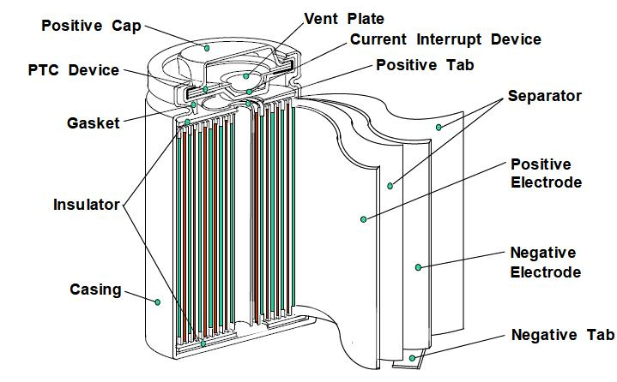

Fig. 1: Cross-sectional view of a cylindrical cell [2]

When charging the battery the opposite reaction occurs, moving the lithium back into the anode. This back and forth motion just coins the term “rocking chair mechanism” which essentially represents how a lithium-ion battery works.[1]

1.1.2 Significant improvements needed

These batteries aren't perfect. There are four main areas where battery technology can get a lot better. Safety, of course, should be the top priority. The safety of batteries needs to be unquestioned and it's very questioned presently. Other factors like energy density always need to come up, cost always needs to come down and cycle life needs to improve. For electric vehicles where the user would want to be able to drive for 10 or 20 years without replacing the battery, it should have an excellent cycle life.[3] The ways that these metrics can be improved are being explored currently. Whilst there's been year-on-year improvements to batteries, there still is a need for significant improvements to achieve mainstream adoption. One of the key metrics is cost, where the frequently cited number to be cost comparable with the internal combustion engine is 100$/kW-h at the pack level which means we need a cell cost to be about 50$/kW-h. Currently, this is just over 200$/kW-h at the pack level and just over 100$/kW-h at the cell level.[4]Though this varies depending on the volume and application. Next, we need to improve the energy density, which represents the range of an electric vehicle, from approximately 250 W-h/kg to about 500 W-h/kg. Also, there is a need to increase the power density which represents the acceleration of the electric vehicle from current levels of about 3 kW/kg to 12 kW/kg.[4] However, as we do this we shouldn't forget about safety as we add more and more energy, it becomes more dangerous and thus there's a need to eliminate the threat of thermal runaway. Lifetime is also critical especially as we aim to apply these batteries in the large-scale grid, energy storage applications and the aim is to hopefully increase the lifetime from about 8 years to 15 years. If we want to electrify more applications, the temperature range over which cells operate must also be improved and as we manufacture more and more of these cells we should also aim to improve their predictability and consistency. Finally, as we start to produce many millions of these cells the sustainability of the system also needs to be considered with the recyclability generally quite low at the moment but with a need to move to near 100% recyclability of the materials soon.

**1.2 History of development**

Batteries were used long before electrical grids or generators were in use. The term battery was first used in 1749 by Benjamin Franklin to describe a set of capacitors he had wired in series to produce a higher voltage. He was using the word in the sense of a set of units connected in series but eventually caught on so well that nowadays we use the term battery to describe even a single power cell. Franklin's capacitors are not batteries in the modern sense, we define a battery as a container consisting of one or more cells in which chemical energy is converted into electricity and used as a source of power. It would be another 11 years before someone used a chemical and reaction to reliably produce electricity. In 1800, Alessandro Volta stacked copper and zinc disks on top of one another separated by pieces of cloth soaked in saltwater. He called this a “voltaic pile” and it was the first source of relatively reliable continuous electricity in a pile form and this is considered the first definitive battery.[5] The zinc disks served as the anode, copper as cathodes and the saltwater was an electrolyte as shown in figure 2.

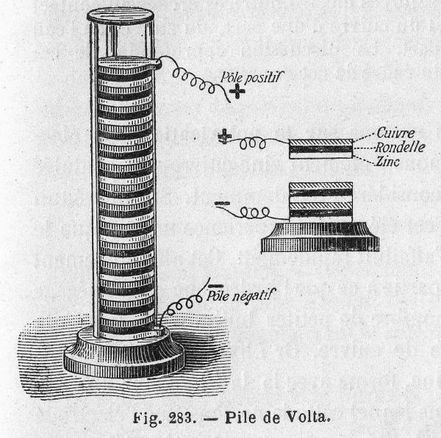

Fig. 2: The voltaic pile [6]

Not long after the “voltaic pile” was created, William Cruikshank came along and improved the design by laying it on its side in a slotted box as shown in figure 3.

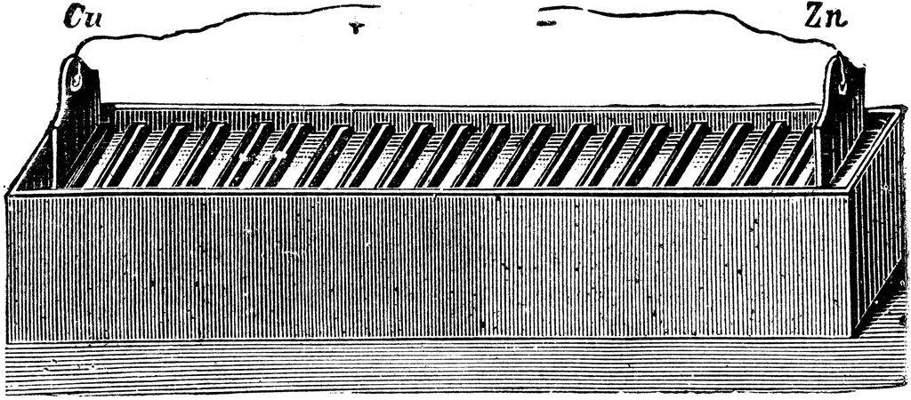

Fig. 3: Trough Battery [7]

This helped prevent the electrolyte from leaking and causing shortness between plates and it was known appropriately enough as a trough of battery. In 1836, John Frederick Daniel pushed the battery further with his Daniel cell. The Daniel cell's defining feature was his use of a porous barrier between two different electrolyte solutions as shown in figure 4.

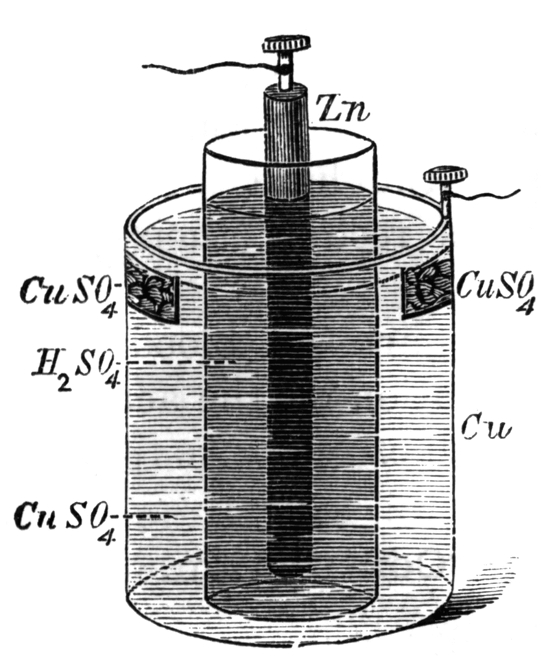

Fig. 4: Daniell cell [8]

When compared to a voltaic pile, the Daniell cell wasn't perfect but it improved reliability, making it suitable for widespread use. A standard for 1 volt is based on the output of one Daniell cell.[11] All of the batteries discussed until now would be considered primary which means once their chemical reactions are depleted, they need to be replaced. A secondary battery can be recharged multiple times and used again without being replaced which is a good thing. In 1859, French physicist Gaston Planté created the first rechargeable battery using a LED anode and a lead dioxide cathode, immersed in sulfuric acid as shown in figure 5.

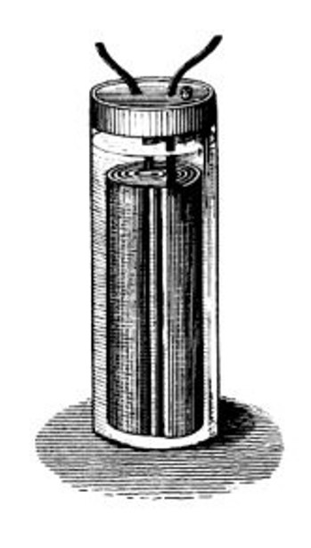

Fig. 5: A Gaston-Planté cell [9]

The chemical reactions inside lead-acid cells could be reversed by passing a reverse current. Though it was a pretty amazing feature, its weight and size made it impractical for most uses, still, it was suitable for some things. LeadLead-acid acid cells are still used in cars today. So far all of these early batteries have used liquid electrolytes which pose pretty obvious challenges to portability but in 1886, Carl Gassner created the first dry cell battery using an electrolyte paste composed of ammonium chloride and Plaster of Paris as shown in figure 6.

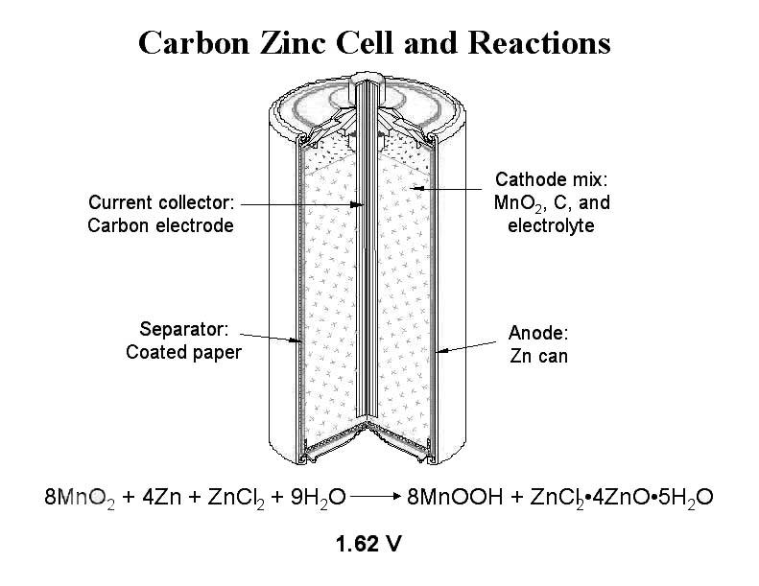

Fig. 6: Carbon Zinc Cell [10]

Because it does not spill and could be used in any orientation, the zinc-carbon cell opened the gates to many new portable uses such as flashlights.[11] The zinc-carbon cell would eventually be refined by the National Carbon Company and evolved into our modern alkaline battery. It is densely packed and has a carbon cathode. Down the centre, there is a thin shell of zinc serving as the anode and a thick pasty black electrolyte.

Nowadays, when we think battery, we think lithium. In fact, we carry around a lithium battery every day in our pocket because of its low density and high electrical potential. Lithium has long been considered an ideal material for use in batteries but it wasn't till the 1970s that the first primary lithium cells were made widely available. Further developments from researchers around the globe led to the release of a lithium-ion battery in 1991 and later the lithium polymer battery in 1997. The major difference between lithium ion and lithium polymer is in the electrolyte. A microporous electrolyte used in lithium polymer batteries means they can deliver the same power as lithium ions but in a lighter flexible package. Otherwise, the chemistry is the same. Inside of a lithium-ion cell, there are layers of anode usually composed of carbon as shown in figure 1. It has a cathode of metal oxide and an electrolyte containing lithium salt. So ultimately batteries come down to chemistry and although many changes are being made to the battery design, the basics remain the same; anode, cathode and electrolyte. [12-14]

**1.3 Applications**

Lithium-ion batteries are available in all sizes and shapes. And that makes them the perfect option for power needs regardless of the size of the system. In addition to that, lithium-ion batteries offer power solutions across the gamut- from energy storage solutions to portable energy solutions. Some of the most familiar and common applications of lithium-ion batteries are:

* Power backups
* Laptops, smartphones and other commonly used consumer electronic goods
* Electric mobility
* Energy Storage Systems

**1.4 Advantages and disadvantages**

One of the significant advantages of a lithium-ion battery is its high energy density. To put it simply, lithium-ion batteries can last way longer between charges while sustaining a high current output. This makes it the ideal battery for most present-day needs. As we spend increasingly more time on our smartphones, lithium-ion batteries can make sure that we are always on the go and spend minimum time attached to a charging wire. Not only while being used, but lithium-ion batteries have an explicit edge when not being used too. When kept inactive, the rate of self-discharge is immensely low. Typically, it is as good as being negligent. Lithium-ion batteries are in demand for their low maintenance. Other cells like Nickel Cadmium batteries have a massive cost of maintenance and ownership. Also, one of the enormous advantages of lithium-ion batteries is that they come in all sizes and shapes which present users with a great number of possibilities to choose from according to their requirements.[15]

However, it must be noted that Lithium-ion batteries come with their blemishes too. Li-ion batteries are being questioned on their safety and have a reputation for catching fire easily. As a result, they need a significant amount of protection to reduce their flammable nature. Also, lithium-ion batteries come at a cost. They are considerably more expensive to buy than the current IC engine technology at the pack level as well as at cell level by around 100$/kW-h as already discussed.[16]

**CHAPTER 2:**

**LITERATURE REVIEW**

**2.1 Literature Review**

2.1.1 Importance of a battery

In short, portable consumer electronics such as mobile phones and laptops have been enabled through the ability to store energy in a compact and energy-dense way. The batteries in these devices generally have a capacity in the order of several watt-hours where 1 W-h means you can discharge the battery at 1W for one hour or 2W for half an hour or half a watt for two hours. Next, there is an increased focus on the decarbonization of transport where the internal combustion engine is one of the major contributors to global carbon dioxide emissions. To address this, many automotive manufacturers are now developing battery electric vehicles where the battery size is of the order of approximately 10 to 100 kW-h.[1] Finally, we need to decarbonize the way we generate electricity that goes into these electric cars otherwise we run the risk of pushing the pollution problem elsewhere in the system. Renewable energy sources such as wind and solar are a good solution here however these are intermittent and therefore there is a need for large-scale energy storage technologies to help buffer supply and demand. In this application, the energy storage devices are of the order of several megawatt-hours.

2.1.2 Battery technologies

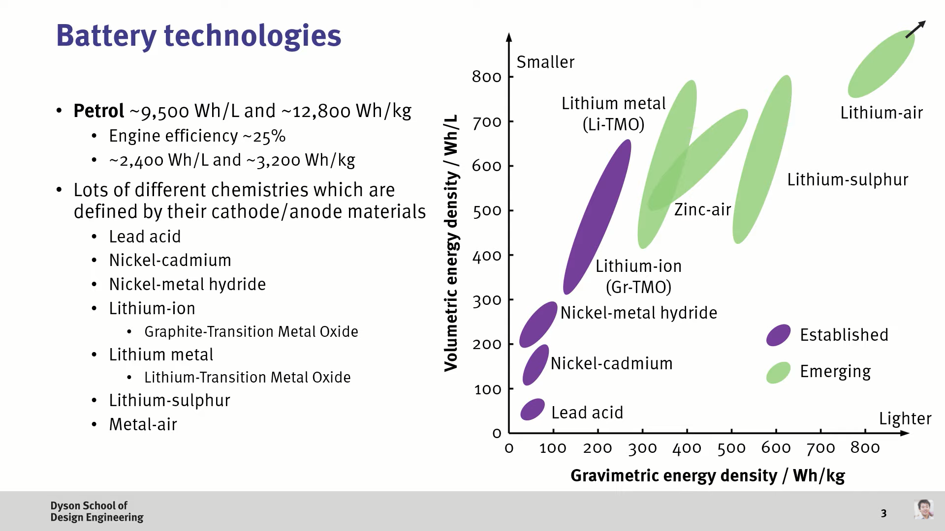

Fig. 7: Energy Density vs Specific Energy of different technologies[17]

There are many different types of battery technology that we often characterize by their volumetric and gravimetric energy densities. As a point of reference, petrol has an approximate energy density of 9500W-h/L and 12,800W-h/kg. However, the efficiency of the internal combustion engine is generally quite poor. If we assume it to be 25% then these numbers drop down to approximately 2,400W-h/L and 3,200W-h/kg.[18] There is a range of different battery technologies with the lead-acid battery being one of the first commercially available ones. This battery was initially used to power things like milk floats and are still used today as starter batteries in cars. The nickel-cadmium battery offered an improvement to the energy density of lead-acid batteries which enabled portable electronics. However, this chemistry was plagued by the memory effect where if a battery is repeatedly charged before all its energy is depleted it will memorize the decreased life cycle and the next time we use it we may notice a significantly shorter operating time. The nickel-metal hydride battery again offered improvements in the capacity as compared to the nickel-cadmium battery without the need for toxic elements such as cadmium. This technology, therefore, found its way into some electric vehicles such as earlier versions of the Toyota Prius. However, the real breakthrough in energy storage technology was with the advent of the modern-day lithium-ion battery which typically consists of a graphite anode and a transition metal oxide cathode. This technology is the one that is powering mobile phones and electric vehicles. Now whilst lithium-ion is well established many people are also researching next-generation technologies, this includes lithium metal anodes where we replace the graphite with pure metallic lithium. The challenge here is preventing the major failure mode called dendrite formation where shards of metallic lithium can cause internal short circuits. Solid-state battery technologies are being heavily researched as a solution. Beyond that, we have lithium-sulfur batteries where the cathode has been replaced with sulfur which has an exceptionally high capacity and low cost. Finally, metal-air batteries such as zinc-air and lithium-air have long been researched as the ultimate solution for energy-dense batteries but still suffer from significant challenges.[19]

At the heart of the battery is the materials that we use. This can be broken down into three main components. In the anode, the aim is to have a high capacity and low voltage i.e., materials that are to the bottom right-hand side of the plot as shown in Figure 8. In the vast majority of lithium-ion batteries, there is a graphite anode due to the low cost and acceptable capacity of the material. Other types of anode material such as lithium titanate also exist however these tend to have a lower capacity and higher voltage which results in a lower energy density. However, there are some high power niche applications for LTO. An ideal material that many people are investigating is silicon due to its relative abundance and high capacity however the problem is that as we charge and discharge silicon it can expand and contract by about 300 per cent which results in polarization of the material and poor lifetime. The current industry solution is therefore to blend graphite and silicon to make composite anodes which is something that Panasonic and Tesla do very successfully. Finally, there is renewed interest in developing metallic lithium anodes which were one of the original battery designs however ultimately fell out of favour due to safety and lifetime concerns. [19-20]

Next, we want cathode materials that again have high capacities but in this case, we want high voltages and therefore we want to be on the top right-hand side part of the plot as shown in Figure 8. One of the first lithium-ion batteries’ cathode materials was lithium cobalt oxide or LCO which is still used in many portable electronic devices due to their relatively good performance metrics however the high cost of cobalt meant that it wasn't practicable for things like electric vehicles. To address the cost problem lithium iron phosphate or LFP was developed which is a much lower cost material however the drawback is that the capacity and voltage are lower limiting its performance. Though it is still used in high power applications and recent years has seen renewed interest as there are several system-level benefits. Lithium manganese oxide or LMO was also a potentially low-cost material however again the performance was less than ideal. This was found in earlier versions of the Nissan Leaf. Then we have the lithium nickel manganese cobalt oxides or NMC and the lithium nickel cobalt aluminium oxide or NCA materials which are the current state-of-the-art which automotive companies use. Here the current trend is to increase the nickel content and decrease the cobalt content to hopefully increase the capacity and reduce the cost. Beyond that, future chemistries are looking to use sulfur due to its extremely low cost and high capacity and also using oxygen since this is abundant and effectively free, however, both of these future chemistries have significant lifetime challenges. Then the final component of interest is the electrolyte which allows lithium ions to move between the anode and cathode. These are normally organic carbonate compounds with a finite stability window. If a material operates outside of this it can decompose, leading to a poor lifetime. This can normally happen if a battery overcharges. Now another feature of interest is that many anode materials are actually outside the stability window of most electrolytes and therefore it should be unstable however we are lucky that in this case a passivating film forms over the anode called the “Solid Electrolyte Interphase” (SEI layer) which stabilizes the material though it does contribute to its long-term degradation. Finally, all of these materials should be cheap, mass-produced and non-flammable. Failure to achieve one of these criteria leads to limited adoption.[21-25]

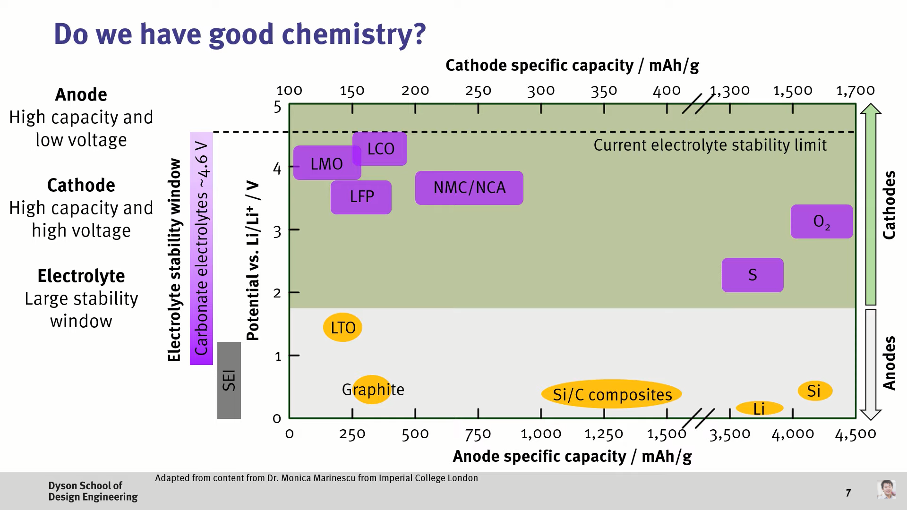

Fig 8: Comparison of different battery chemistries [25]

Whilst both the anode and cathode are important, often the cathode is where the majority of the cost is and if we look at ideal characteristics we want from the cathode we can see that we need good specific energy, power, safety, lifetime and cost. Lithium cobalt oxide or LCO has reasonable specific energy but the cost was the main drawback. Lithium iron phosphate has a whole host of ideal characteristics however the main drawback is the specific energy; though the increased safety can have system-level benefits to warrant its use. Lithium Manganese Oxide (LMO) chemistry has ideal cost and safety characteristics but the lifetime and capacity have meant that this chemistry has limited use now. Thus the main automotive thrust has been on NMC and NCA which have ideal specific capacities but still need improvements. Here the move has been towards higher Nickel content where the Nickel broadly represents an increase in capacity, the Cobalt helps with stability and rate capability and the Manganese helps with safety and cost. [26-28]

The most common chemistries which are well known and commercialized by multiple companies are:

1. NMC (Nickel Manganese Cobalt)
2. LFP (Lithium Ferro Phosphate or Lithium Iron Phosphate)
3. NCA (Nickel Cobalt Aluminium Oxide)
4. LMO (Lithium Manganese Oxide)
5. LCO (Lithium Cobalt Oxide)

Li-ion cell is made of:

Cathode: NMC, LFP, LMO, NCA, or LCO

Anode: Carbon (In Graphite form) or LTO

Separator: Ceramic or similar material

Electrolyte: Lithium salt (e.g. LiPF6), in organic solvent (e.g. Ethylene Carbonate)

Current Collectors: Aluminium and Copper.

**Table 1:** Comparison of different cathode materials

| **Battery** | **Energy Density**  **(Wh/kg)** | **Cyclability**  **(Cycles)** | **Advantages** | **Disadvantages** |
| --- | --- | --- | --- | --- |
| LCO | 150–190 | 500–1000 | Technological maturity,  Low-self discharge,  High discharge voltage | High cost,  low inherent safety |
| LMO | 100–140 | 1000–1500 | High inherent safety,  Cobalt-free | Low energy density |
| LFP | 90–140 | up to 2000 | High inherent safety | Low energy density |
| NCA | 200–250 | 1000–1500 | Low cobalt content | Capacity fade at  elevated temperature |
| NMC | 140–200 | 1000–2000 | Low cobalt content | Safety issues in  Ni-rich batteries |

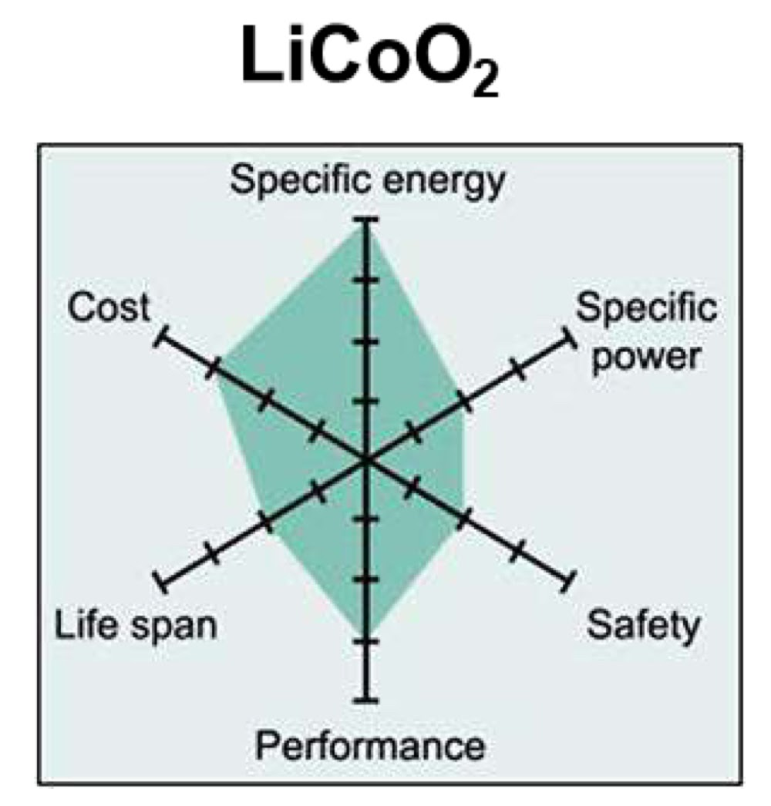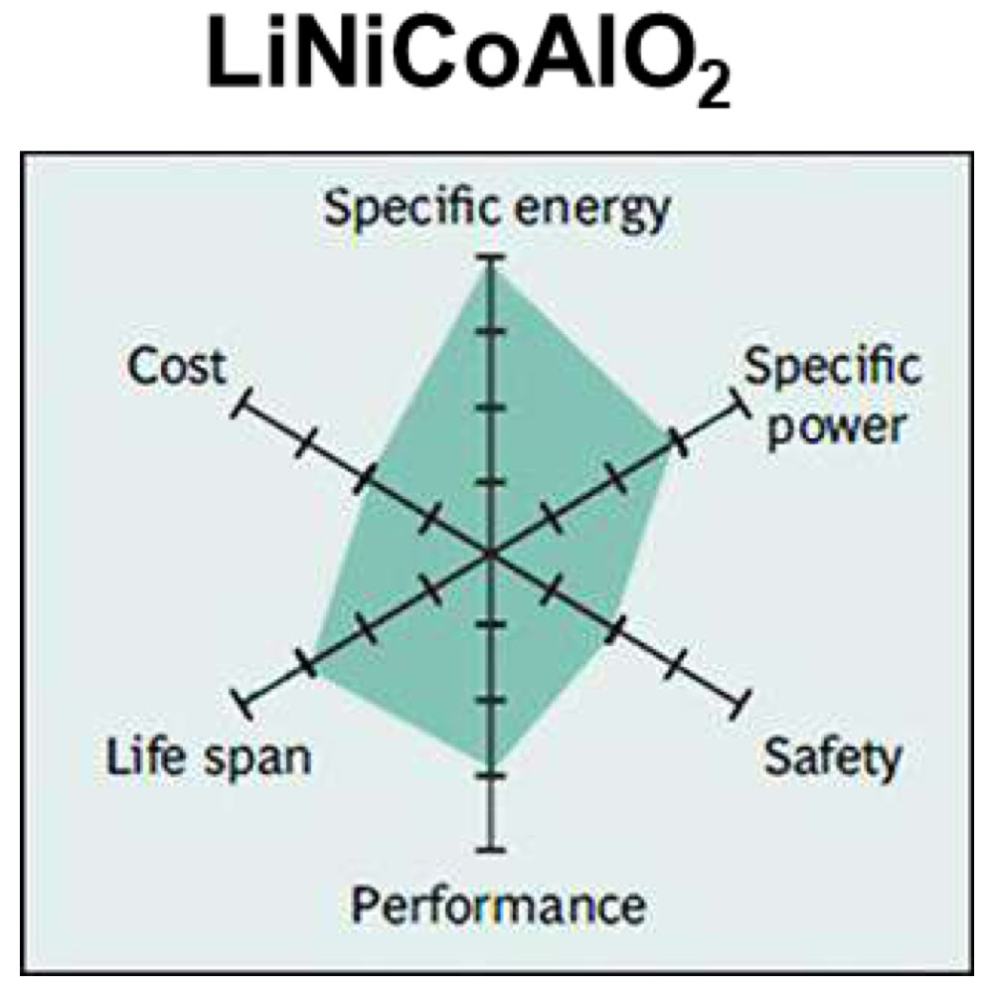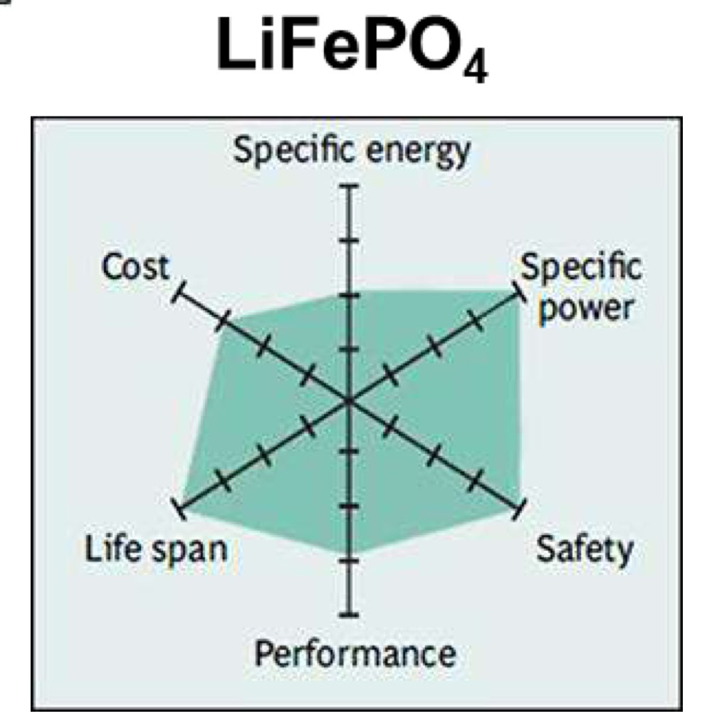

(a) (b) (c)

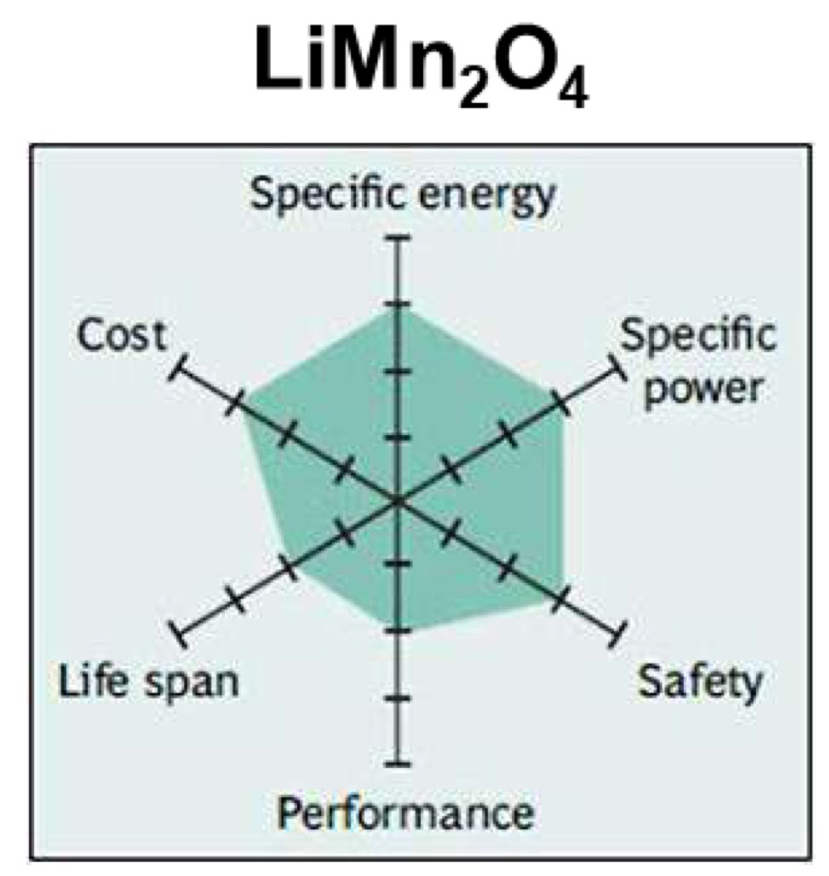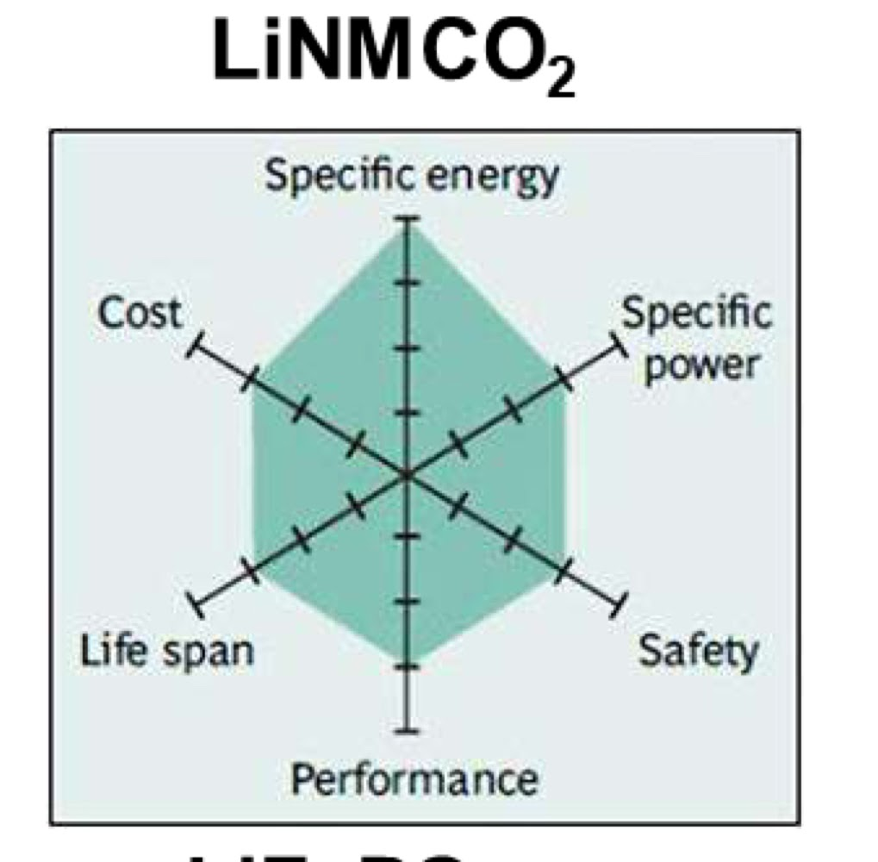

(d) (e)

Fig. 9: Comparison of various cathode materials namely (a) LCO (b) NCA (c) LFP (d) LMO and (e) NMC

*(not to scale)

Lithium Nickel Manganese Cobalt Oxide (NMC), Lithium Iron Phosphate (LiFePO4) and Lithium Manganese Oxide (LMO) stand out as being superior among these candidates.[21-30]

2.1.3 Battery industry structure

To solve some of these problems, it's useful to have a high-level perspective on the battery industry and supply chain. In the first instance, we have the raw materials with key elements including lithium, nickel, cobalt and copper. Here, where the materials come from can be important and also how ethically these are sourced. The abundance of these materials is also an important factor. It is estimated that Lithium can fulfil the needs for the electrification of vehicles all around the globe and can last for another 350 years. Before that, Cobalt and Nickel may get completely exhausted. Next, these raw materials are converted into precursors needed for active material manufacturing. Here, key considerations include what form of lithium precursor is used i.e a lithium carbonate or lithium hydroxide. The processing method used also is important in terms of the quality of the material produced. These active materials are then mixed and coated onto their current collectors to make electrodes. The manufacturing conditions are critical for good performance. These electrodes are made into cells with different form factors with a resulting formation cycle that can define their future performance. These cells are then taken by tier 1 automotive suppliers or high volume automotive companies and made into modules and packs with thermal management systems and battery management systems. Then these are put into vehicles for the lifetime of their use where the load profile and environmental conditions can define their performance. At the end of life when a pack has reached 80 per cent of its original capacity these can either be used in second life applications such as stationary energy storage or be recycled.[31]

2.1.4 Battery manufacturing

As we scale up batteries to the millions needed for electric vehicles we also need to consider how these are made. In the first instance, we take the active materials of choice and then mix these with conductive carbon additives, a polymeric binder and a solvent. The ink is then mixed and coated on two current collectors after which the electrode is dried to remove the solvent and then calendered or compressed to increase the volumetric energy density. These electrodes are then cut and stacked into the cell form factor of choice and then the electrolyte is introduced with the cell then is sealed. This has to be done in dry room conditions to avoid undesirable reactions. Next, we need to charge the cell as most lithium-ion batteries are assembled in their uncharged state. This has to be done very slowly in the first instance to form a good cycle life and we term this step of the process “formation”. Finally, these cells are integrated into a system with a thermal management system and a battery management system. There are many steps in this process and therefore there's still a lot of room for innovation in the battery manufacturing space.[32]

2.1.5 Important terminologies

If we have a closer look at the performance of different lithium-ion batteries there are often two key metrics that we often talk about. The first is the C rate which is the normalized measure of current relative to its cell capacity. We define the C rate as the current divided by the capacity of the cell. Next, we have the capacity of the cell which is measured in terms of its amp hours. This is the discharge current multiplied by the time for which it maintains this current for. Considering an example of a 4.8 amp-hour cell, if we discharge the cell at 4.8 amps, this is 1C and this should last for approximately 1 hour. If we decrease the current to 2.4 amps this is 0.5C which should last for 2 hours and if we increase the current to 9.6 amps this is 2C and this should last for half an hour.[1]

2.1.6 Discharge curves

Expanding on what the discharge curves look like in terms of their voltage-time response we get this plot as shown in figure 10 for the three different C rates. Higher voltage means that we are at a higher state of charge and have more energy left and as we increase the current the discharge time is shorter. However, to have a fair comparison of performance we should plot this as a voltage against capacity plot as shown in (b) where it's more evident now that the accessible capacity is less and also the losses are higher when we increase the current as the voltage is lower.[33]

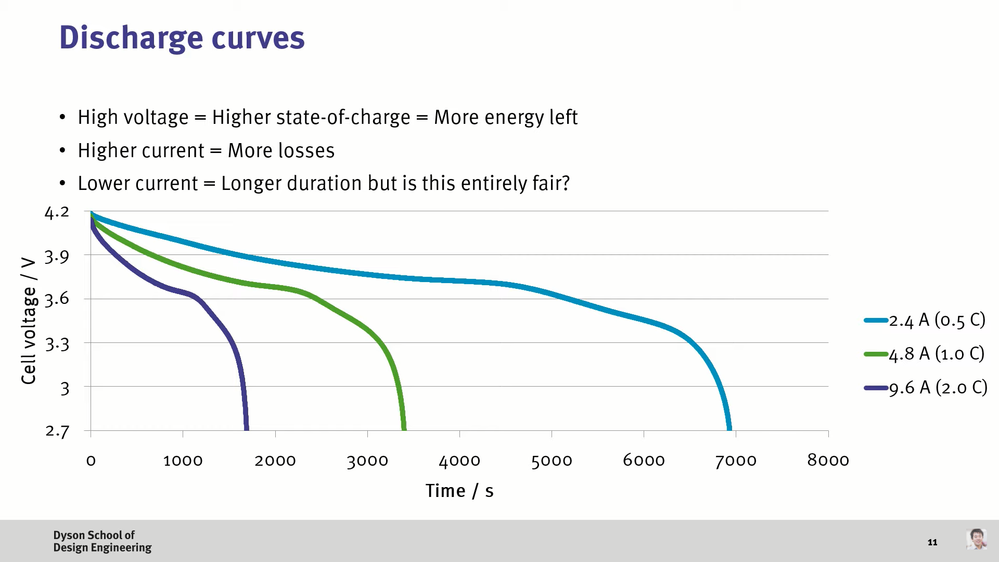

(a)

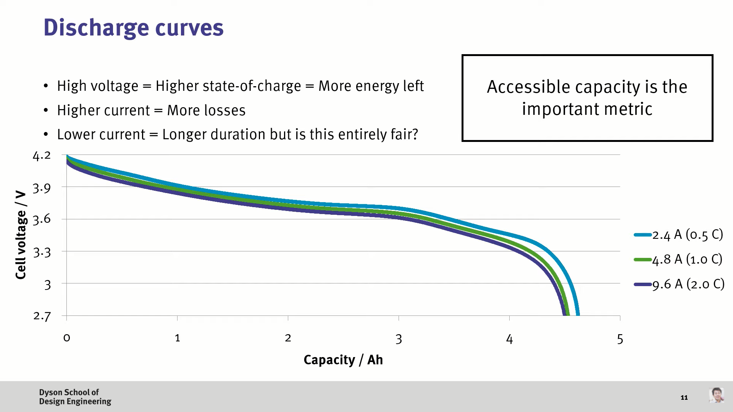

(b)

Fig. 10: Discharge curves of a LIB; (a) Voltage vs time (b) Voltage vs Capacity [33]

2.1.7 Energy of the cell

While C rate and capacity are key metrics, we ultimately care about the energy of the cell. A battery datasheet of a Panasonic 18650 cylindrical cell is shown, which has a nominal or average voltage of 3.6 volts and a capacity of 3.35 amp hours which gives us the energy of 12W-h. The cell has a weight of 47.5 grams which then allows us to work out that this cell has an energy density of 254W-h/kg. As shown in figure (b), we have another datasheet from an A123 lithium-ion phosphate 26650 cell. Here, the nominal voltage is lower at 3.3V with a capacity of 2.3Ah giving energy of 7.6W-h. This cell has a mass of 70 grams and therefore gives us specific energy of 108W-h/kg, which highlights the fact that LFP has a lower energy density than other chemistries such as NMC and NCA. However, again energy is just one metric and certain cells such as LFP often have ideal power and lifetime characteristics. In this case, these two examples are of an energy cell and a power cell respectively.

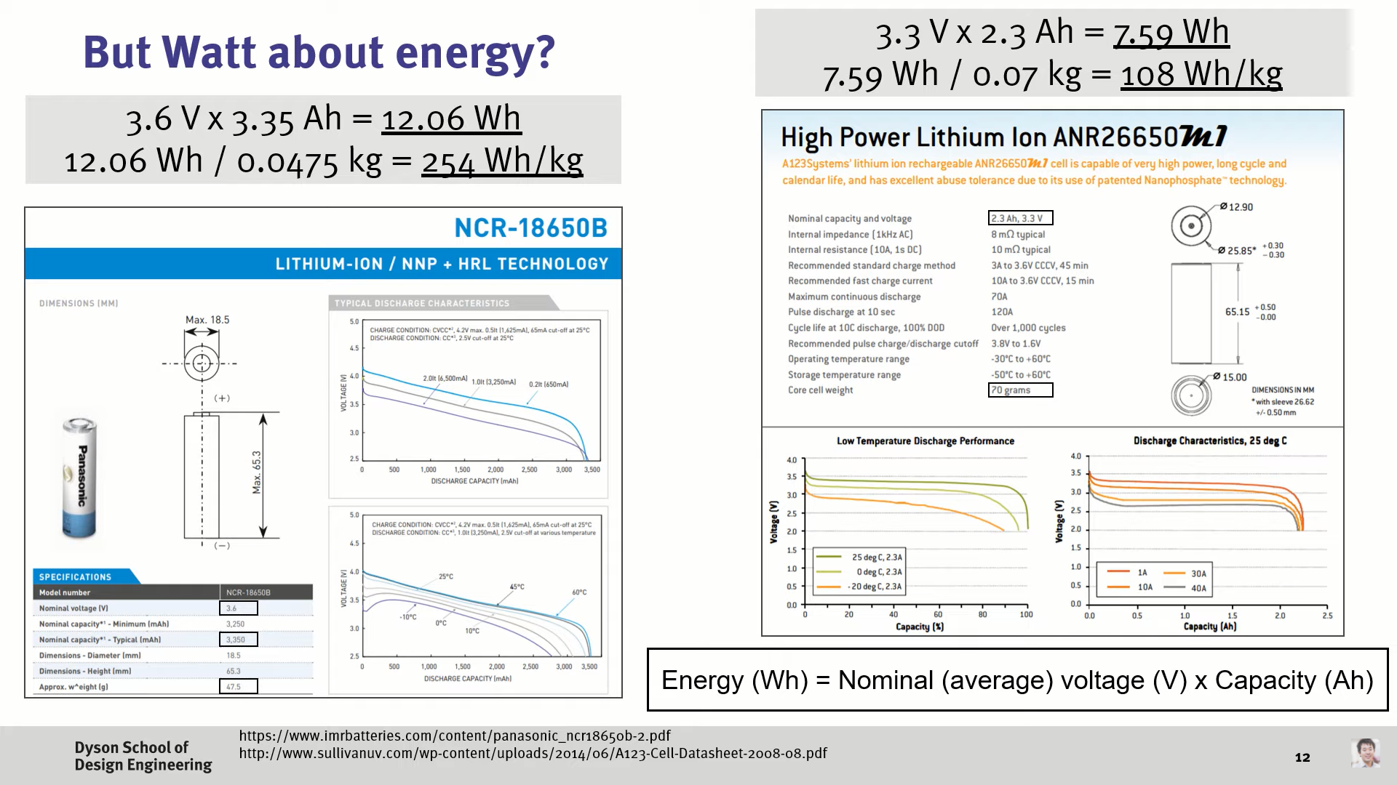

(a)



(b)

Fig. 11: Battery datasheets of (a) Energy Cell [34] (b) Power Cell [35]

2.1.8 Form factors

There are different form factors of cells. We can get prismatic cells, which generally have a high degree of mechanical stability since they have a rigid case and are often used in applications such as phones. Cylindrical batteries again have good mechanical stabilities and generally are the lowest cost form factor due to ease of manufacturing, with these being used in power tools and many electric vehicles. The most common cylindrical cell is the 18650 which means that this cell has a diameter of 18 millimetres and is 65 millimetres long. Finally, we have the pouch cell which in theory has the highest energy density of the different form factors but has low mechanical stability due to the lack of a rigid case. This is often found in applications such as drones where the energy density is even more critical.[36]

**2.2 Objective Formulation**

* To estimate the influence of cathode materials on the power output characteristics of Lithium-ion batteries. In the presence of high capacity electrodes, lithiation and delithiation are some of the main factors responsible for the short life span of Lithium-based batteries. The SOC dependent mechanical properties of cathode materials will be estimated through molecular dynamics simulations using a Large-scale Atomic/Molecular Massively Parallel Simulator (LAMMPS).[37]
* Study the performance of the battery, considering the real-time operating conditions like temperature, humidity, to name a few.
* To estimate overall power losses with time associated with the battery pack under operating conditions.
* Devise the methods to reduce the power losses and enhance the battery life, e.g.: battery thermal management systems.

**2.3 Methodology/ Work Plan**

* Make the unit cell structure of the cathode material in VESTA (short for Visualisation for Electronic Structural Analysis). It is a 3D visualization programme for structural models, volumetric data such as electron/nuclear densities, and crystal morphologies.
* Convert the crystal structure to a LAMMPS data file using Atomsk[38]. It is a free, Open Source command-line program dedicated to the creation, manipulation, and conversion of data files for atomic-scale simulations.
* Simulate the material in LAMMPS subjected to different strain rates (C-rates) and study the behaviour of the cathode material under observation.

**CHAPTER 3:**

**MODEL DEVELOPMENT**

**Model Development:** Spinel LiMn2O4 is one of the most attractive energy storage materials due to its low cost and reversible and fast intercalation and deintercalation of Li ions. The LiMn2O4 spinel structure (space-group: Fd3m), consists of oxygen ions in a close-packed array, occupying the 32e position, Mn ions occupy the octahedral site 16d, and Li+ occupies the tetrahedral 8a site. All ions of the LMO unit cell are in a cubical structure in the Fd3m space group. Using the data[39] given below, the unit cell of LMO was made using VESTA[40] (short for Visualisation for Electronic Structural Analysis). It is a 3D visualization programme for structural models, volumetric data such as electron/nuclear densities, and crystal morphologies.

Space Group: F d -3 m

a = 8.24500 Å, α = 90.0000°

b = 8.24500 Å, β = 90.0000°

c = 8.24500 Å, γ = 90.0000°

V = 560.4953 Å3

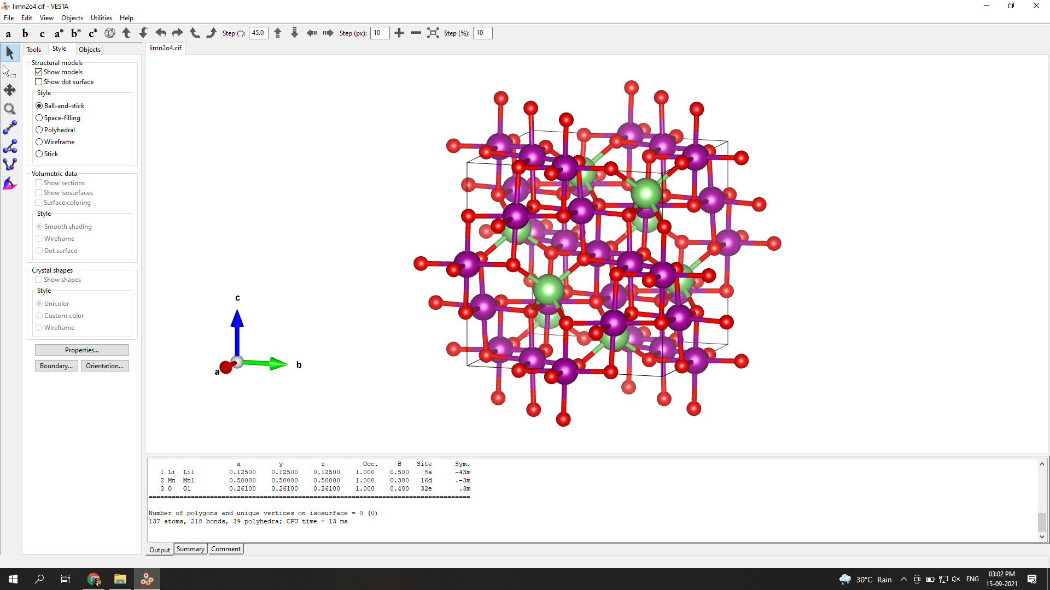

Fig. 12: Unit cell of LMO made using “VESTA”

Structure parameters:

x y z Occ. B Site Sym.

1. Li Li1 0.12500 0.12500 0.12500 1.000 0.500 8a -43m

2. Mn Mn1 0.50000 0.50000 0.50000 1.000 0.300 16d .-3m

3. O O1 0.26100 0.26100 0.26100 1.000 0.400 32e .3m

**CHAPTER 4:**

**RESULTS AND DISCUSSION**

**CHAPTER 5:**

**CONCLUSION AND FUTURE SCOPE**

**5.1 Conclusion**

**5.2** **Future Scope**

**CHAPTER 6:**

**REFERENCES**

[1] Warner, John T. The handbook of lithium-ion battery pack design: chemistry, components, types and terminology. Elsevier, 2015.

[2] <http://elecorevenergy.com/cylindrical-lithium-cells/>

[3] Sendek, Austin D., Qian Yang, Ekin D. Cubuk, Karel-Alexander N. Duerloo, Yi Cui, and Evan J. Reed. "Holistic computational structure screening of more than 12000 candidates for solid lithium-ion conductor materials." Energy & Environmental Science 10, no. 1 (2017): 306-320.

[4] Zackrisson, Mats, Lars Avellán, and Jessica Orlenius. "Life cycle assessment of lithium-ion batteries for plug-in hybrid electric vehicles–Critical issues." Journal of Cleaner Production 18, no. 15 (2010): 1519-1529.

[5] Whittingham, M. Stanley. "History, evolution, and future status of energy storage." Proceedings of the IEEE 100, no. Special Centennial Issue (2012): 1518-1534.

[6] <https://learn.sparkfun.com/tutorials/what-is-a-battery/history>

[7] https://etc.usf.edu/clipart/61100/61104/61104_battery.html

[8] <https://etc.usf.edu/clipart/8100/8156/dan_battery_8156.html>

[9] https://www.upsbatterycenter.com/blog/types-of-lead-acid-batteries/

[10]<https://www.acs.org/content/acs/en/education/whatischemistry/landmarks/drycellbattery.html>

[11] Heth, Christopher L. "Energy on demand: A brief history of the development of the battery." Substantia 3, no. 2 (2019): 73-82.

[12] Reddy, Mogalahalli V., Alain Mauger, Christian M. Julien, Andrea Paolella, and Karim Zaghib. "Brief history of early lithium-battery development." Materials 13, no. 8 (2020): 1884.

[13] Li, Matthew, Jun Lu, Zhongwei Chen, and Khalil Amine. "30 years of lithium‐ion batteries." Advanced Materials 30, no. 33 (2018): 1800561.

[14] Scrosati, Bruno. "History of lithium batteries." Journal of solid state electrochemistry 15, no. 7 (2011): 1623-1630.

[15] Zubi, Ghassan, Rodolfo Dufo-López, Monica Carvalho, and Guzay Pasaoglu. "The lithium-ion battery: State of the art and future perspectives." Renewable and Sustainable Energy Reviews 89 (2018): 292-308.

[16] Lu, Languang, Xuebing Han, Jianqiu Li, Jianfeng Hua, and Minggao Ouyang. "A review on the key issues for lithium-ion battery management in electric vehicles." Journal of power sources 226 (2013): 272-288.

[17] Miao, Yu, Patrick Hynan, Annette Von Jouanne, and Alexandre Yokochi. "Current Li-ion battery technologies in electric vehicles and opportunities for advancements." Energies 12, no. 6 (2019): 1074.

[18] Sutopo, W., D. I. Maryanie, A. Purwanto, and M. Nizam. "A comparative value chains analysis of battery technologies for electric vehicles." In 2013 Joint International Conference on Rural Information & Communication Technology and Electric-Vehicle Technology (rICT & ICeV-T), pp. 1-5. IEEE, 2013.

[19] Manzetti, Sergio, and Florin Mariasiu. "Electric vehicle battery technologies: From present state to future systems." Renewable and Sustainable Energy Reviews 51 (2015): 1004-1012.

[20] Chen, Kangda, Fuquan Zhao, Han Hao, and Zongwei Liu. "Selection of lithium-ion battery technologies for electric vehicles under China’s new energy vehicle credit regulation." Energy Procedia 158 (2019): 3038-3044.

[21] Yu, Haijun, and Haoshen Zhou. "High-energy cathode materials (Li2MnO3–LiMO2) for lithium-ion batteries." The journal of physical chemistry letters 4, no. 8 (2013): 1268-1280.

[22] Hong, Jian, Feng Wang, Xiaoliang Wang, and Jason Graetz. "LiFexMn1− xPO4: A cathode for lithium-ion batteries." Journal of Power Sources 196, no. 7 (2011): 3659-3663.

[23] Xu, Bo, Danna Qian, Ziying Wang, and Ying Shirley Meng. "Recent progress in cathode materials research for advanced lithium ion batteries." Materials Science and Engineering: R: Reports 73, no. 5-6 (2012): 51-65.

[24] Omar, Noshin, P. Van den Bossche, Grietus Mulder, M. Daowd, J. M. Timmermans, Joeri Van Mierlo, and S. Pauwels. "Assessment of performance of lithium iron phosphate oxide, nickel manganese cobalt oxide and nickel cobalt aluminum oxide based cells for using in plug-in battery electric vehicle applications." In 2011 IEEE Vehicle Power and Propulsion Conference, pp. 1-7. IEEE, 2011.

[25] Mohamed, Nourhan, and Nageh K. Allam. "Recent advances in the design of cathode materials for Li-ion batteries." RSC Advances 10, no. 37 (2020): 21662-21685.

[26] Marincaş, Alexandru-Horatiu, Firuţa Goga, Sorin-Aurel Dorneanu, and Petru Ilea. "Review on synthesis methods to obtain LiMn 2 O 4-based cathode materials for Li-ion batteries." Journal of Solid State Electrochemistry 24, no. 3 (2020): 473-497.

[27] Zhang, YiDi, Yi Li, XinHui Xia, XiuLi Wang, ChangDong Gu, and JiangPing Tu. "High-energy cathode materials for Li-ion batteries: A review of recent developments." Science China Technological Sciences 58, no. 11 (2015): 1809-1828.

[28] Huang, Yiqing, Yuh-Chieh Lin, David M. Jenkins, Natasha A. Chernova, Youngmin Chung, Balachandran Radhakrishnan, Iek-Heng Chu et al. "Thermal stability and reactivity of cathode materials for Li-ion batteries." ACS applied materials & interfaces 8, no. 11 (2016): 7013-7021.

[29] Longo, R. C., F. T. Kong, K. C. Santosh, M. S. Park, J. Yoon, D-H. Yeon, J-H. Park, S-G. Doo, and Kyeongjae Cho. "Phase stability of Li–Mn–O oxides as cathode materials for Li-ion batteries: Insights from ab initio calculations." Physical Chemistry Chemical Physics 16, no. 23 (2014): 11233-11242.

[30] Dou, Shumei. "Review and prospect of layered lithium nickel manganese oxide as cathode materials for Li-ion batteries." Journal of Solid State Electrochemistry 17, no. 4 (2013): 911-926.

[31] Pelegov, Dmitry V., and José Pontes. "Main drivers of battery industry changes: electric vehicles—a market overview." Batteries 4, no. 4 (2018): 65.

[32] Wood III, David L., Jianlin Li, and Seong Jin An. "Formation challenges of lithium-ion battery manufacturing." Joule 3, no. 12 (2019): 2884-2888.

[33] Traub, Lance W. "Calculation of constant power lithium battery discharge curves." Batteries 2, no. 2 (2016): 17.

[34] <https://www.batteryspace.com/prod-specs/NCR18650B.pdf>

[35] <https://datasheetspdf.com/pdf/1424845/A123Systems/ANR26650M1-B/1>

[36] Sankaran, Ganesh, and S. Venkatesan. "Standardization of electric vehicle battery pack geometry form factors for passenger car segments in India." Journal of Power Sources 502 (2021): 230008.

[37] Plimpton, Steve. "Fast parallel algorithms for short-range molecular dynamics." Journal of computational physics 117, no. 1 (1995): 1-19.

[38] Hirel, Pierre. "Atomsk: A tool for manipulating and converting atomic data files." Computer Physics Communications 197 (2015): 212-219.

[39] Rossouw, M. H., A. De Kock, L. A. De Picciotto, M. M. Thackeray, W. I. F. David, and R. M. Ibberson. "Structural aspects of lithium-manganese-oxide electrodes for rechargeable lithium batteries." Materials research bulletin 25, no. 2 (1990): 173-182.

[40] Momma, Koichi, and Fujio Izumi. "VESTA 3 for three-dimensional visualization of crystal, volumetric and morphology data." Journal of applied crystallography 44, no. 6 (2011): 1272-1276.

**APPENDIX:**